Create an instance, log-in with ssh as username and password more or less.

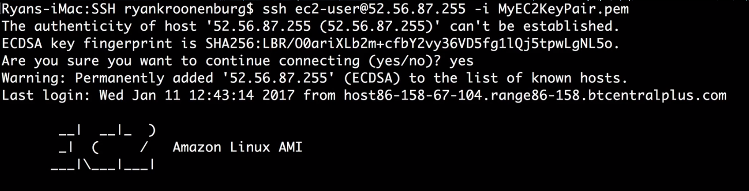

sudo su just means we elevate our privileges right away as well. And press clear.

Theres a lot of things that we do just to be able to test ECB. We need to have an EC2 instance, we need to get logged in with the SSH. We also need to check if acpahe is turned on.

Service httpd status should show is running.. If we need to have it running we can press service httpd start. If it is not installed then we can enter yum install httpd -y and it will have it started very quickly.

Enter chckconfig httpd on to have it start everytime the instance is turned on. We can check the status again to see if its running if youd like. Cd /var/www/html

I can press nano index.html to make a text file. Control X to get out and save it. Here I can type whatever I need and it will live on the server.

2 Types of Load Balancers: Application and Classic.

Application Load Balancers work on Layer 7. It is the preferred method.

Classic is the old way of doing it and is still on the exam.

Step 4 – Configure Health Check is the guts of the Load Balancer.